11/12/2023

Chakradhar Bhogapurapu

Star Schema

Star Schema is a multidimensional model which is used for data warehouse. It uses more space and takes less time for the execution of queries. Normalization is not used and it is easily designed. It has less number of foreign keys. It has less complexity.

Snowflake Schema

Snowflake schema contains fact tables, dimension tables as well as sub dimension tables are contained. It uses less space. It takes more time for the execution of queries. Here in snowflake schema, both normalization and denormalization is used. Snowflake has complex design. It has more number of foreign keys and low data redundancy. It is difficult to understand when compared to star schema.

Database Schema Diagrams

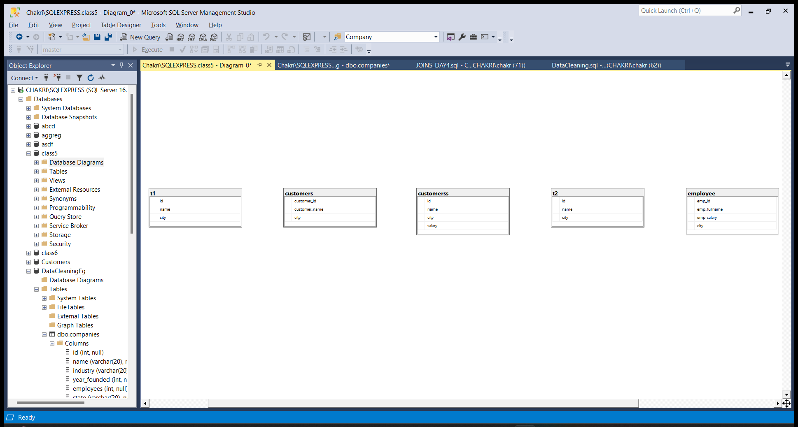

Data Cleaning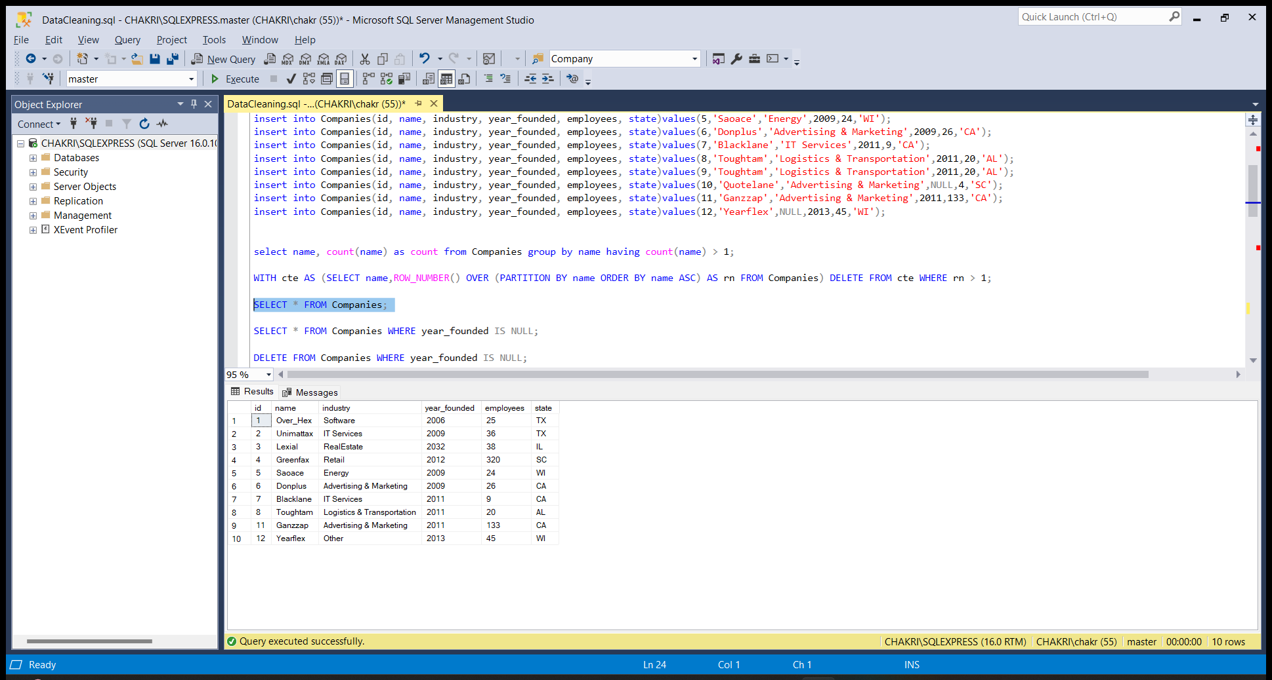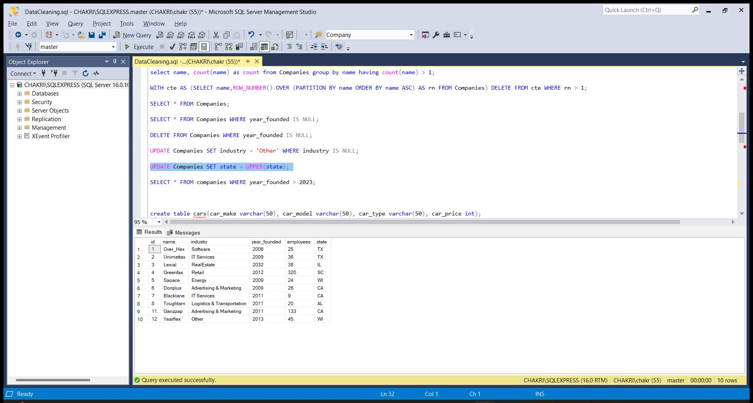

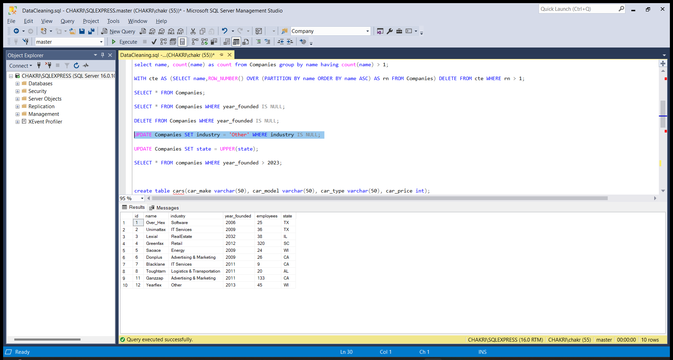

Partition By